Insulin Bone Markers

Tim Vigers & Laura Pyle

30 January 2019

Descriptive statistics of full cohort at baseline

|  |  |
| --- | --- |
|  | Overall |
| n | 58 |
| Gender = M (%) | 30 (51.7) |
| InsDeliveryMethod = Pump (%) | 34 (58.6) |
| CurrUseCGM = Yes (%) | 25 (43.1) |
| AgeAtConsent (median [IQR]) | 25.00 [20.25, 34.00] |
| t1dduration (median [IQR]) | 5.50 [3.00, 9.00] |
| insulin_kilo (mean (sd)) | 0.58 (0.22) |
| hba1c (mean (sd)) | 7.04 (0.92) |
| bmi (mean (sd)) | 24.23 (3.09) |
| ins0 (median [IQR]) | 9.40 [5.55, 13.33] |
| calcium (median [IQR]) | 9.30 [9.03, 9.60] |
| po4 (median [IQR]) | 63.50 [56.25, 73.50] |
| cpep0 (median [IQR]) | 0.04 [0.01, 0.11] |
| girAUC (median [IQR]) | 60390.00 [7095.00, 65707.50] |

Descriptive statistics by c-peptide concentration at baseline. There was only one ‘medium’ c-peptide participant, so they were included in the high c-peptide group.

|  |  |  |  |  |  |
| --- | --- | --- | --- | --- | --- |
|  | high | low | negative | p | test |
| n | 5 | 34 | 19 |  |  |
| Gender = M (%) | 4 (80.0) | 17 (50.0) | 9 (47.4) | 0.522 | exact |
| InsDeliveryMethod = Pump (%) | 3 (60.0) | 18 (52.9) | 13 (68.4) | 0.564 | exact |
| CurrUseCGM = Yes (%) | 2 (40.0) | 17 (50.0) | 6 (31.6) | 0.437 | exact |
| AgeAtConsent (median [IQR]) | 22.00 [21.00, 28.00] | 27.00 [21.25, 35.50] | 21.00 [20.00, 30.00] | 0.449 | nonnorm |
| t1dduration (median [IQR]) | 3.00 [3.00, 4.00] | 4.00 [2.00, 5.75] | 10.00 [8.50, 13.00] | <0.001 | nonnorm |
| insulin_kilo (mean (sd)) | 0.70 (0.22) | 0.50 (0.21) | 0.69 (0.19) | 0.004 |  |
| hba1c (mean (sd)) | 6.94 (1.25) | 6.78 (0.84) | 7.51 (0.82) | 0.020 |  |
| bmi (mean (sd)) | 25.33 (3.23) | 23.48 (3.00) | 25.27 (2.97) | 0.091 |  |
| ins0 (median [IQR]) | 12.00 [11.50, 12.40] | 8.70 [5.32, 13.07] | 9.90 [6.75, 15.00] | 0.738 | nonnorm |
| calcium (median [IQR]) | 9.30 [9.10, 9.70] | 9.30 [9.03, 9.60] | 9.20 [9.05, 9.60] | 0.643 | nonnorm |
| po4 (median [IQR]) | 93.00 [65.00, 99.00] | 64.50 [57.25, 67.00] | 59.00 [56.00, 74.50] | 0.175 | nonnorm |
| cpep0 (median [IQR]) | 0.02 [0.02, 0.04] | 0.08 [0.04, 0.12] | 0.01 [0.01, 0.01] | <0.001 | nonnorm |
| girAUC (median [IQR]) | 61387.50 [11812.50, 64305.00] | 60862.50 [7676.25, 66382.50] | 32295.00 [3999.38, 63155.62] | 0.493 | nonnorm |

# Correlations

Baseline insulin correlated with bone markers, full cohort

|  |  |  |
| --- | --- | --- |
|  | R | P-Value |
| P1NP0 | 0.05 | 0.73 |
| CTX0 | -0.24 | 0.07 |
| osteocalcin0 | 0.00 | 0.99 |
| IGF0 | 0.12 | 0.35 |
| cpep0 | -0.15 | 0.27 |
| ON.0 | 0.07 | 0.62 |
| SOST.0 | 0.07 | 0.61 |
| calcium | -0.05 | 0.71 |
| po4 | -0.02 | 0.88 |

Baseline insulin correlated with bone markers, low c-peptide group

|  |  |  |
| --- | --- | --- |
|  | R | P-Value |
| P1NP0 | -0.03 | 0.88 |
| CTX0 | -0.33 | 0.05 |
| osteocalcin0 | -0.01 | 0.94 |
| IGF0 | 0.12 | 0.51 |
| cpep0 | -0.25 | 0.16 |
| ON.0 | 0.13 | 0.47 |
| SOST.0 | 0.15 | 0.39 |
| calcium | -0.09 | 0.63 |
| po4 | 0.03 | 0.87 |

Baseline insulin correlated with bone markers, high c-peptide group

|  |  |  |
| --- | --- | --- |
|  | R | P-Value |
| P1NP0 | 0.26 | 0.67 |
| CTX0 | -0.85 | 0.07 |
| osteocalcin0 | -0.40 | 0.51 |
| IGF0 | -0.95 | 0.01 |
| cpep0 | 0.15 | 0.81 |
| ON.0 | 0.34 | 0.58 |
| SOST.0 | -0.23 | 0.71 |
| calcium | 0.66 | 0.22 |
| po4 | -0.32 | 0.60 |

Baseline insulin correlated with bone markers, negative c-peptide group

|  |  |  |
| --- | --- | --- |
|  | R | P-Value |
| P1NP0 | 0.19 | 0.43 |
| CTX0 | 0.21 | 0.39 |
| osteocalcin0 | 0.14 | 0.57 |
| IGF0 | 0.43 | 0.07 |
| cpep0 | -0.03 | 0.91 |
| ON.0 | -0.09 | 0.72 |
| SOST.0 | -0.18 | 0.46 |
| calcium | -0.09 | 0.72 |
| po4 | -0.11 | 0.66 |

120 min insulin correlated with bone markers, full cohort

|  |  |  |
| --- | --- | --- |
|  | R | P-Value |
| P1NP120 | 0.16 | 0.24 |
| CTX120 | 0.12 | 0.37 |
| osteocalcin120 | -0.05 | 0.69 |
| IGF120 | -0.04 | 0.75 |
| cpep120 | 0.15 | 0.27 |
| ON.120 | 0.04 | 0.79 |
| SOST.120 | 0.12 | 0.36 |

120 min insulin correlated with bone markers, low c-peptide group

|  |  |  |
| --- | --- | --- |
|  | R | P-Value |
| P1NP120 | 0.41 | 0.02 |
| CTX120 | -0.04 | 0.83 |
| osteocalcin120 | -0.15 | 0.38 |
| IGF120 | -0.16 | 0.36 |
| cpep120 | 0.08 | 0.65 |
| ON.120 | -0.14 | 0.44 |
| SOST.120 | 0.19 | 0.28 |

120 min insulin correlated with bone markers, high c-peptide group

|  |  |  |
| --- | --- | --- |
|  | R | P-Value |
| P1NP120 | -0.54 | 0.35 |
| CTX120 | 0.81 | 0.09 |
| osteocalcin120 | 0.71 | 0.18 |
| IGF120 | 0.61 | 0.27 |
| cpep120 | 0.97 | 0.00 |
| ON.120 | 0.25 | 0.69 |
| SOST.120 | 0.76 | 0.13 |

120 min insulin correlated with bone markers, negative c-peptide group

|  |  |  |
| --- | --- | --- |
|  | R | P-Value |
| P1NP120 | -0.11 | 0.66 |
| CTX120 | 0.19 | 0.43 |
| osteocalcin120 | -0.14 | 0.55 |
| IGF120 | -0.11 | 0.66 |
| cpep120 | NA | NA |
| ON.120 | 0.12 | 0.63 |
| SOST.120 | -0.21 | 0.39 |

Percent change in insulin correlated with bone markers, full cohort

|  |  |  |
| --- | --- | --- |
|  | R | P-Value |
| P1NP_perc_change | 0.17 | 0.21 |
| CTX_perc_change | -0.08 | 0.53 |
| osteocalcin_perc_change | -0.06 | 0.68 |
| IGF_perc_change | 0.09 | 0.49 |
| cpep_perc_change | -0.08 | 0.53 |
| ON._perc_change | 0.08 | 0.55 |
| SOST._perc_change | 0.10 | 0.47 |

Percent change in insulin correlated with bone markers, low c-peptide group

|  |  |  |
| --- | --- | --- |
|  | R | P-Value |
| P1NP_perc_change | 0.19 | 0.31 |
| CTX_perc_change | -0.13 | 0.46 |
| osteocalcin_perc_change | -0.05 | 0.77 |
| IGF_perc_change | 0.02 | 0.92 |
| cpep_perc_change | -0.10 | 0.58 |
| ON._perc_change | 0.10 | 0.58 |
| SOST._perc_change | 0.02 | 0.89 |

Percent change in insulin correlated with bone markers, high c-peptide group

|  |  |  |
| --- | --- | --- |
|  | R | P-Value |
| P1NP_perc_change | 0.69 | 0.20 |
| CTX_perc_change | -0.40 | 0.51 |
| osteocalcin_perc_change | 0.41 | 0.49 |
| IGF_perc_change | -0.06 | 0.92 |
| cpep_perc_change | 0.02 | 0.97 |
| ON._perc_change | 0.04 | 0.95 |
| SOST._perc_change | 0.07 | 0.91 |

Percent change in insulin correlated with bone markers, negative c-peptide group

|  |  |  |
| --- | --- | --- |
|  | R | P-Value |
| P1NP_perc_change | -0.12 | 0.62 |
| CTX_perc_change | 0.17 | 0.49 |
| osteocalcin_perc_change | -0.12 | 0.62 |
| IGF_perc_change | 0.31 | 0.19 |
| cpep_perc_change | 0.10 | 0.70 |
| ON._perc_change | 0.04 | 0.87 |
| SOST._perc_change | 0.30 | 0.21 |

Minute 120 GIR correlated with bone markers, full cohort

|  |  |  |
| --- | --- | --- |
|  | R | P-Value |
| P1NP120 | -0.03 | 0.85 |
| CTX120 | 0.01 | 0.95 |
| osteocalcin120 | -0.01 | 0.92 |
| IGF120 | -0.07 | 0.62 |
| cpep120 | -0.08 | 0.54 |
| ON.120 | 0.02 | 0.89 |
| SOST.120 | 0.19 | 0.16 |

Minute 120 GIR correlated with bone markers, low c-peptide group

|  |  |  |
| --- | --- | --- |
|  | R | P-Value |
| P1NP120 | -0.01 | 0.97 |
| CTX120 | 0.08 | 0.65 |
| osteocalcin120 | 0.03 | 0.87 |
| IGF120 | -0.06 | 0.73 |
| cpep120 | -0.19 | 0.28 |
| ON.120 | -0.08 | 0.65 |
| SOST.120 | 0.07 | 0.68 |

Minute 120 GIR correlated with bone markers, high c-peptide group

|  |  |  |
| --- | --- | --- |
|  | R | P-Value |
| P1NP120 | -0.43 | 0.47 |
| CTX120 | -0.58 | 0.31 |
| osteocalcin120 | 0.17 | 0.79 |
| IGF120 | -0.74 | 0.15 |
| cpep120 | -0.39 | 0.51 |
| ON.120 | 0.65 | 0.24 |
| SOST.120 | 0.35 | 0.56 |

Minute 120 GIR correlated with bone markers, negative c-peptide group

|  |  |  |
| --- | --- | --- |
|  | R | P-Value |
| P1NP120 | -0.02 | 0.93 |
| CTX120 | 0.03 | 0.90 |
| osteocalcin120 | -0.20 | 0.43 |
| IGF120 | 0.07 | 0.78 |
| cpep120 | NA | NA |
| ON.120 | 0.03 | 0.90 |
| SOST.120 | 0.43 | 0.08 |

GIR-AUC correlated with percent change in bone markers, full cohort

|  |  |  |
| --- | --- | --- |
|  | R | P-Value |
| P1NP_perc_change | -0.10 | 0.46 |
| CTX_perc_change | -0.08 | 0.54 |
| osteocalcin_perc_change | -0.27 | 0.04 |
| IGF_perc_change | -0.17 | 0.20 |
| cpep_perc_change | 0.06 | 0.67 |
| ON._perc_change | 0.16 | 0.24 |
| SOST._perc_change | -0.16 | 0.23 |

GIR-AUC correlated with percent change in bone markers, low c-peptide group

|  |  |  |
| --- | --- | --- |
|  | R | P-Value |
| P1NP_perc_change | -0.21 | 0.24 |
| CTX_perc_change | 0.21 | 0.23 |
| osteocalcin_perc_change | -0.40 | 0.02 |
| IGF_perc_change | -0.04 | 0.84 |
| cpep_perc_change | 0.13 | 0.46 |
| ON._perc_change | 0.06 | 0.75 |
| SOST._perc_change | -0.33 | 0.06 |

GIR-AUC correlated with percent change in bone markers, high c-peptide group

|  |  |  |
| --- | --- | --- |
|  | R | P-Value |
| P1NP_perc_change | 0.10 | 0.88 |
| CTX_perc_change | -0.90 | 0.04 |
| osteocalcin_perc_change | -0.80 | 0.11 |
| IGF_perc_change | -0.87 | 0.05 |
| cpep_perc_change | -0.14 | 0.83 |
| ON._perc_change | 0.31 | 0.61 |
| SOST._perc_change | -0.47 | 0.43 |

GIR-AUC correlated with percent change in bone markers, negative c-peptide group

|  |  |  |
| --- | --- | --- |
|  | R | P-Value |
| P1NP_perc_change | 0.24 | 0.34 |
| CTX_perc_change | -0.47 | 0.05 |
| osteocalcin_perc_change | 0.17 | 0.50 |
| IGF_perc_change | -0.34 | 0.17 |
| cpep_perc_change | -0.21 | 0.40 |
| ON._perc_change | 0.33 | 0.18 |
| SOST._perc_change | 0.17 | 0.51 |

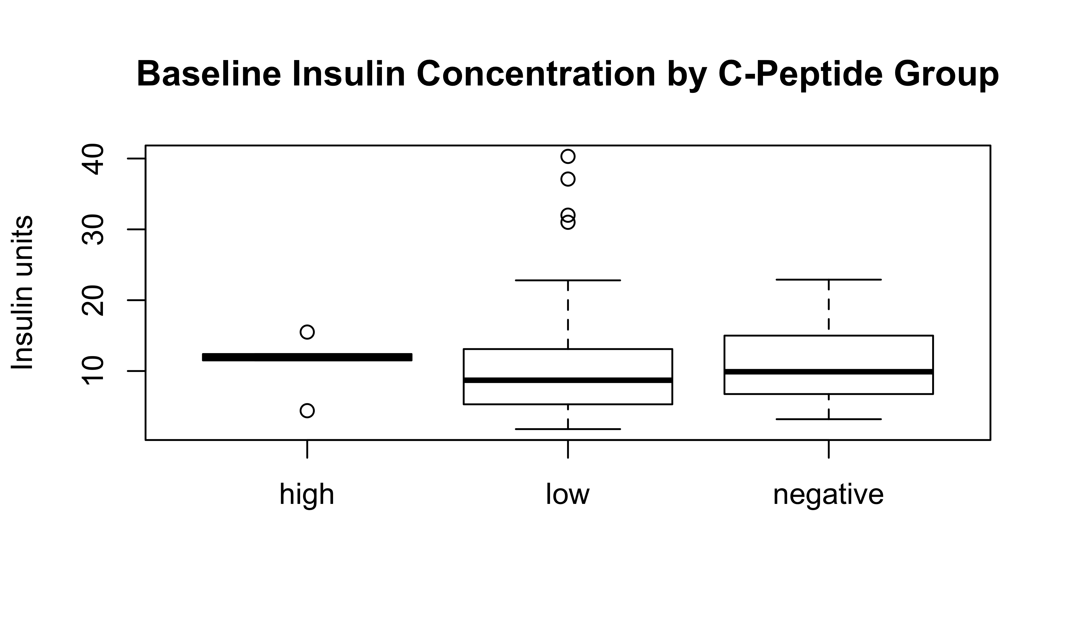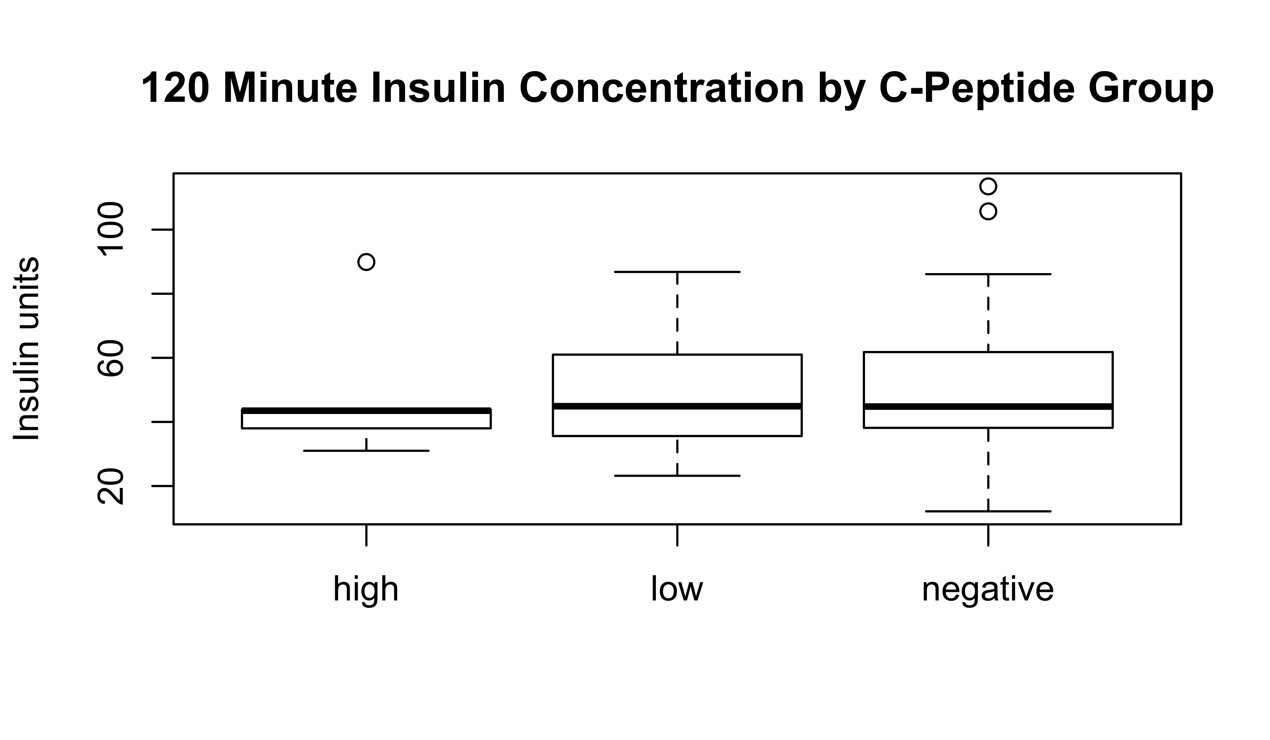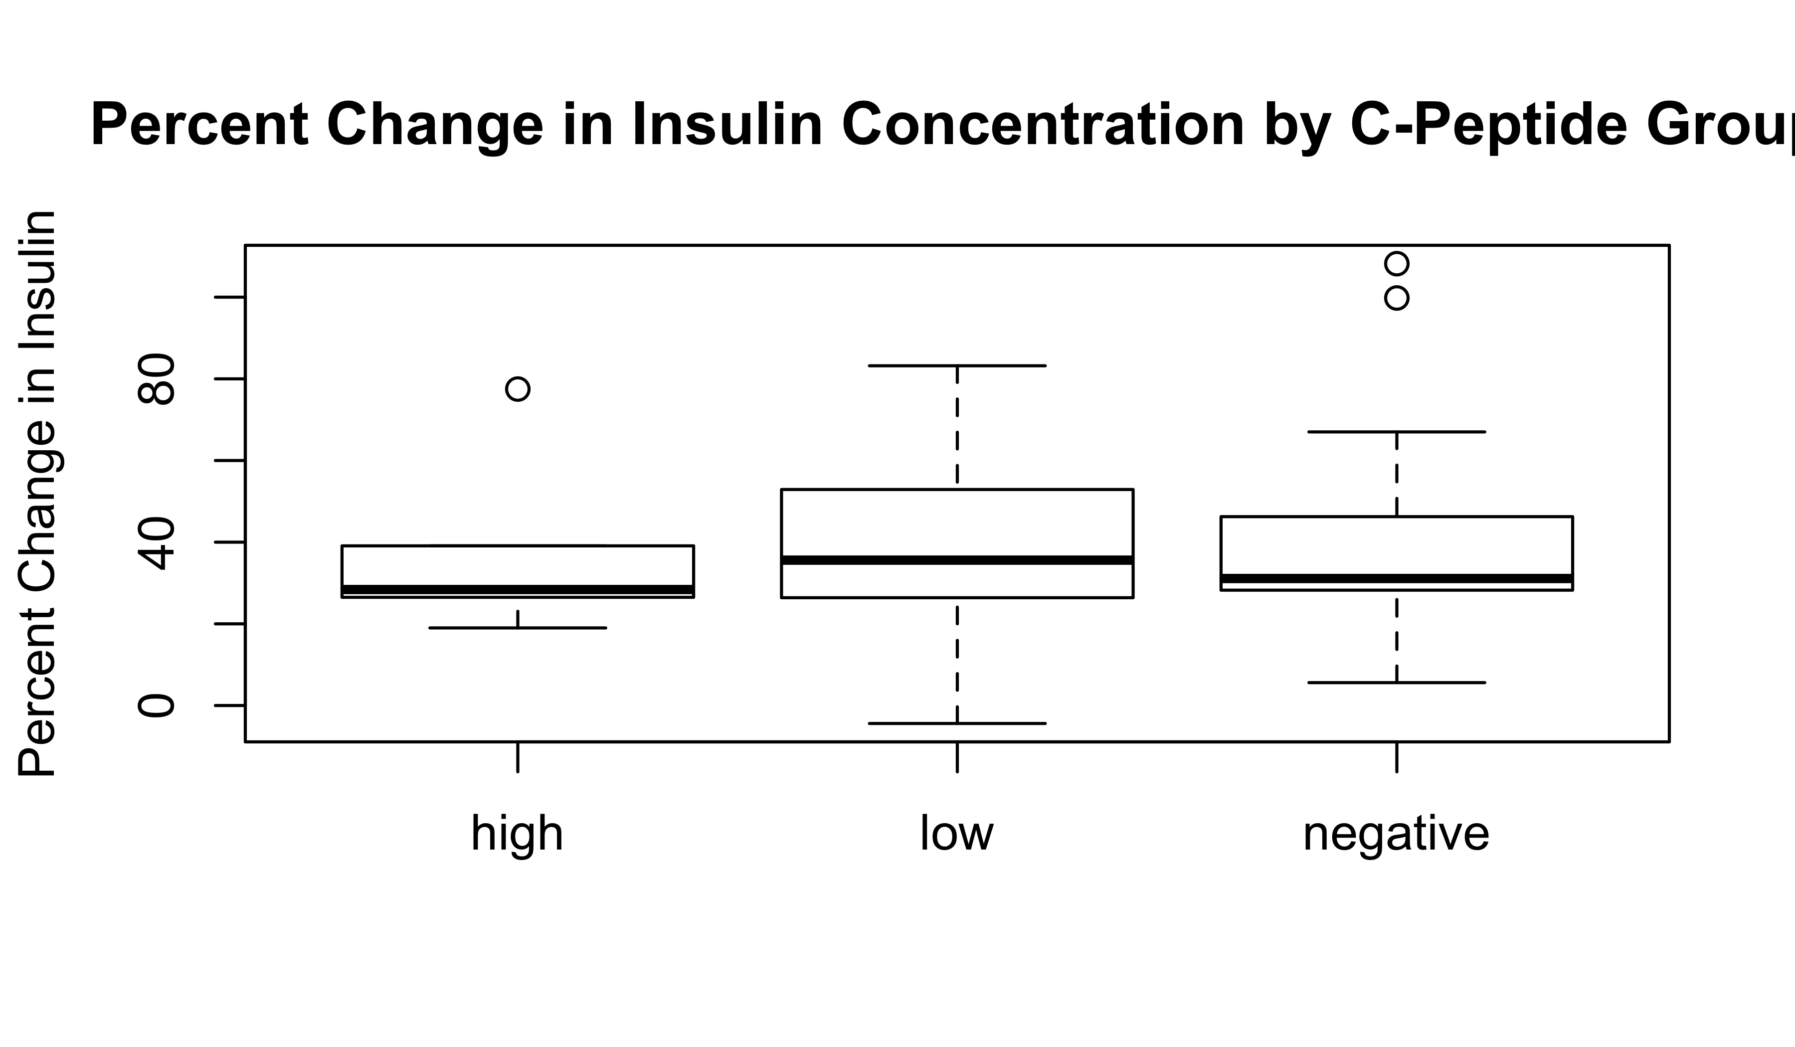

# Plots of bone marker change 0 minute to 120 minute, by c-peptide group.

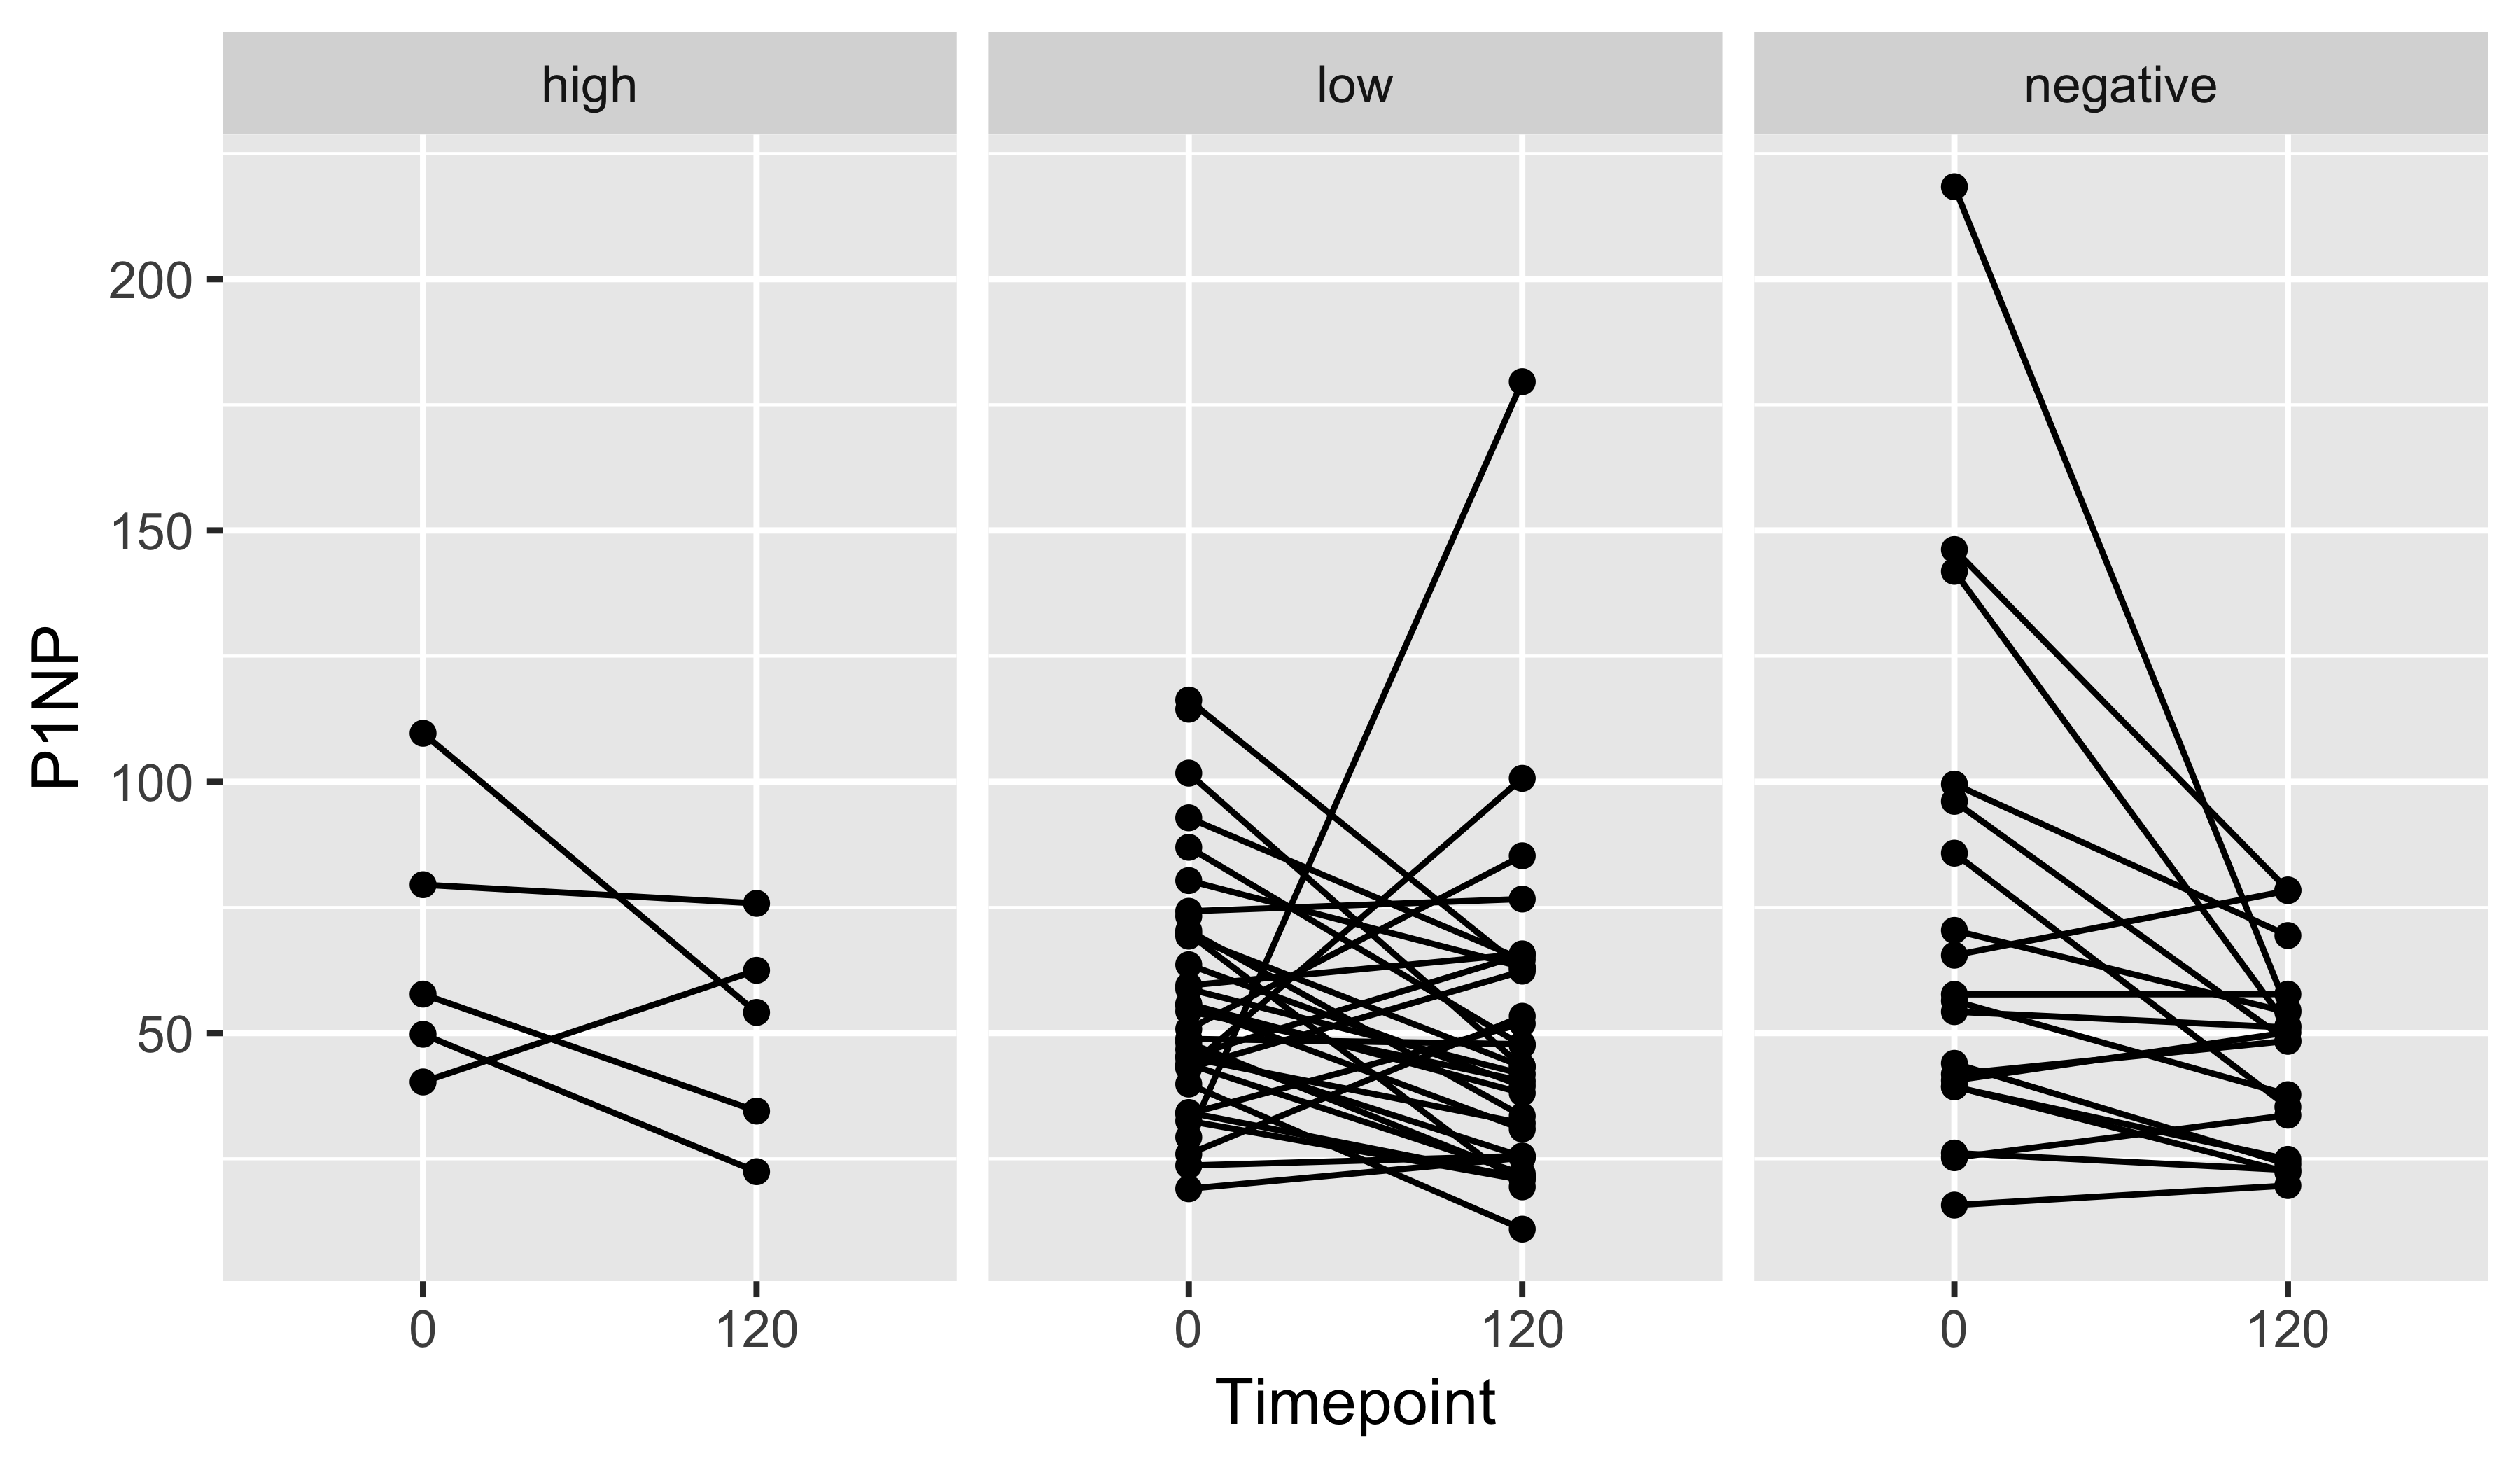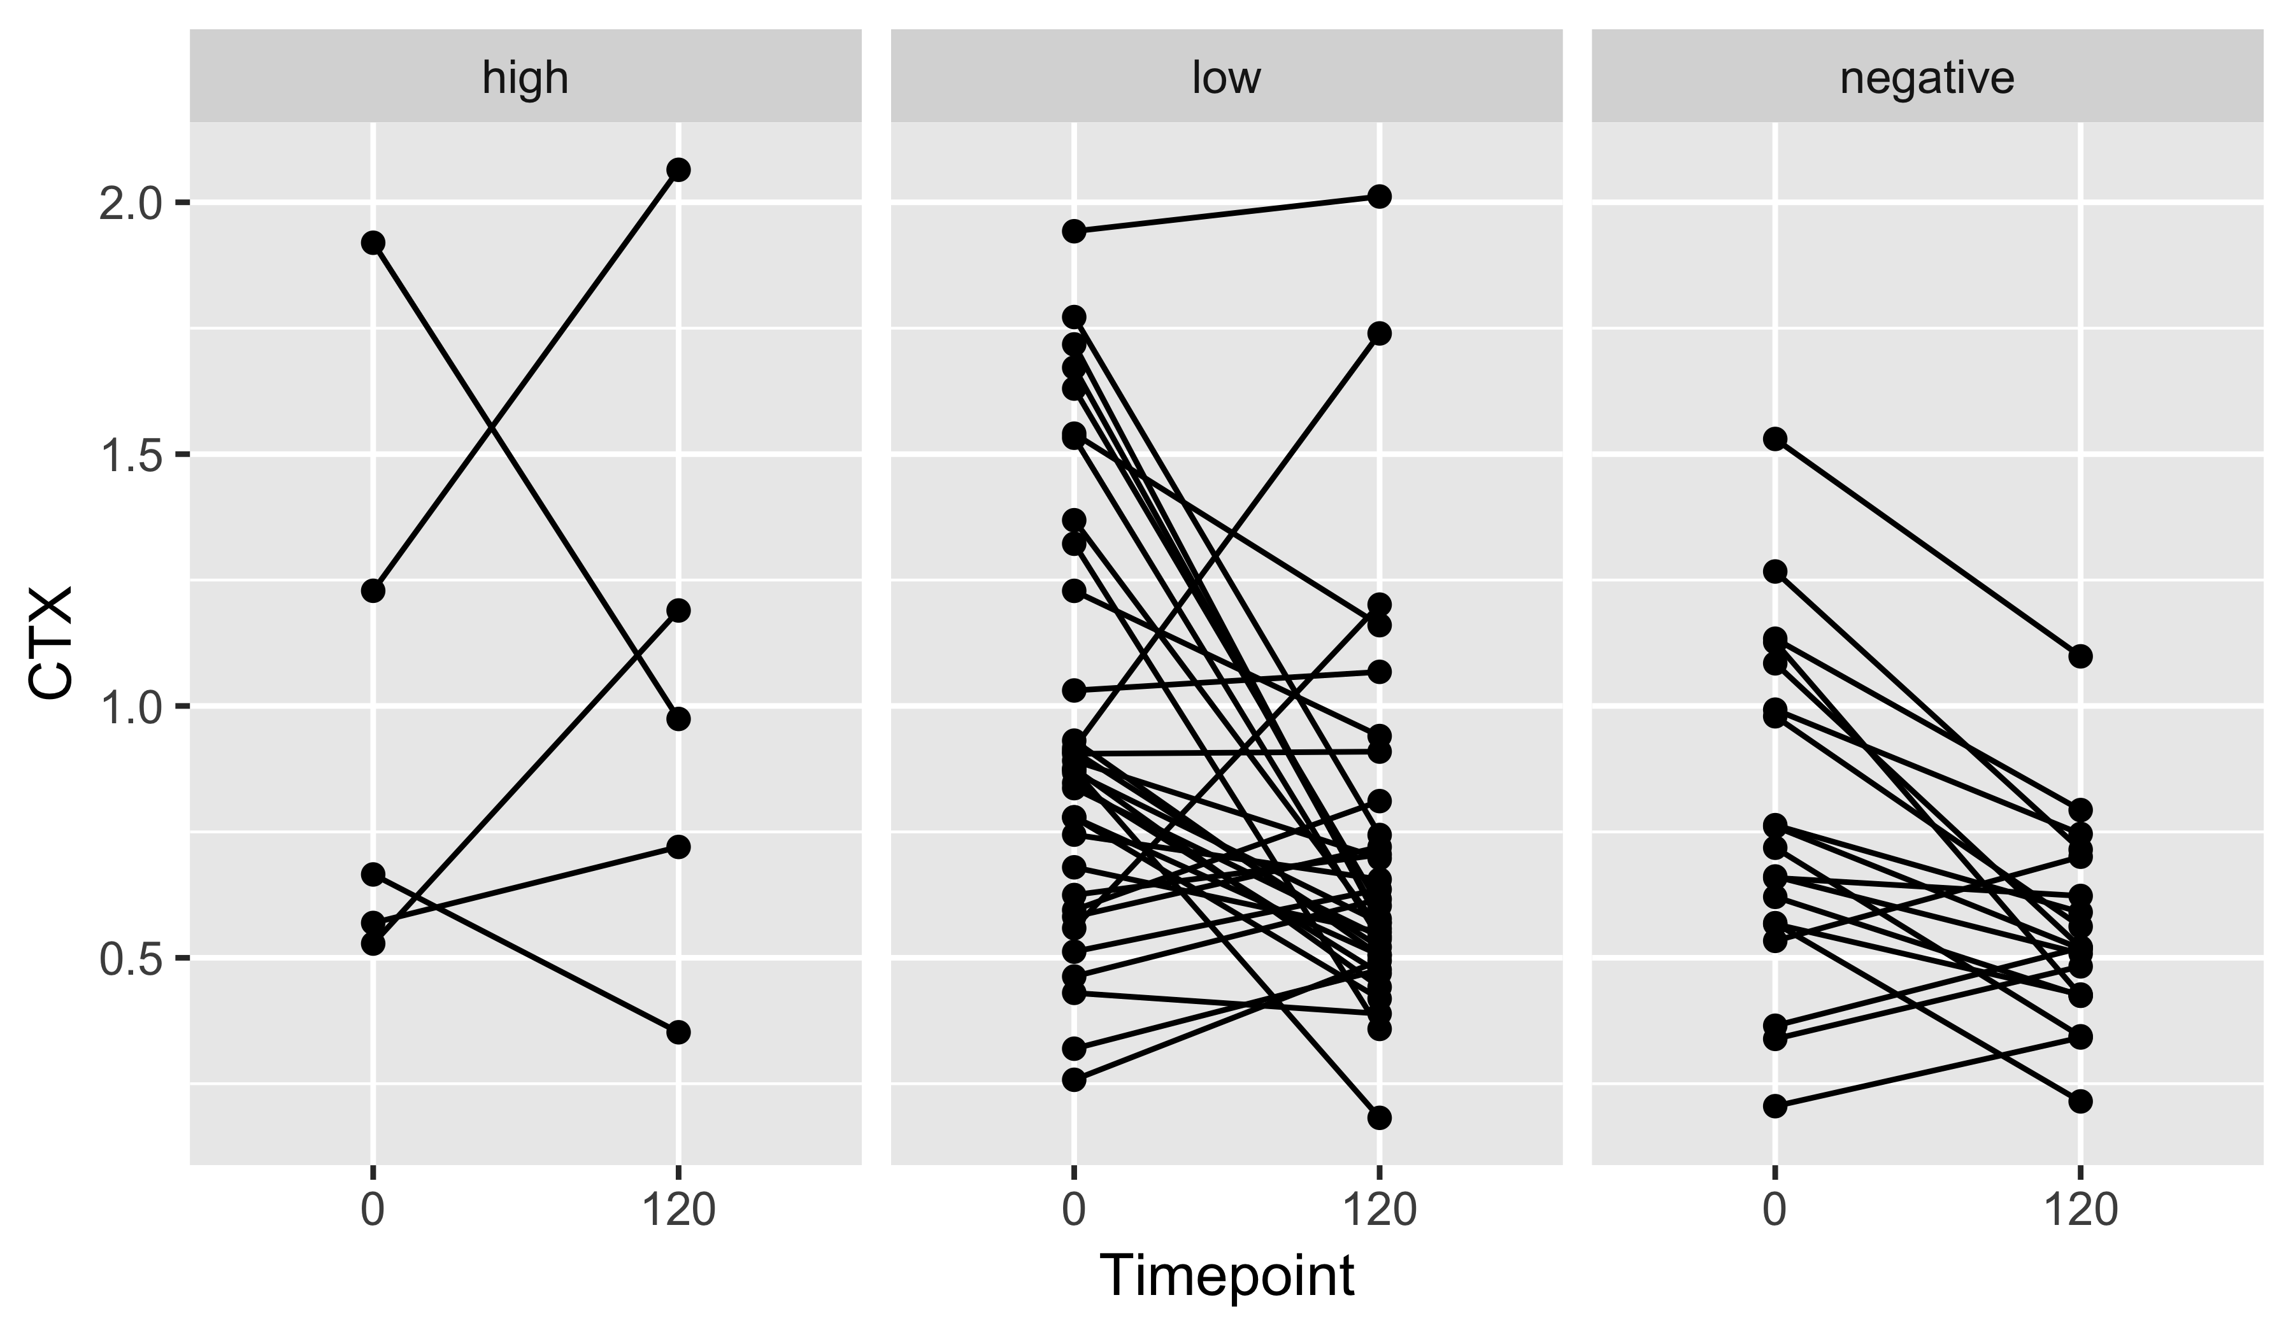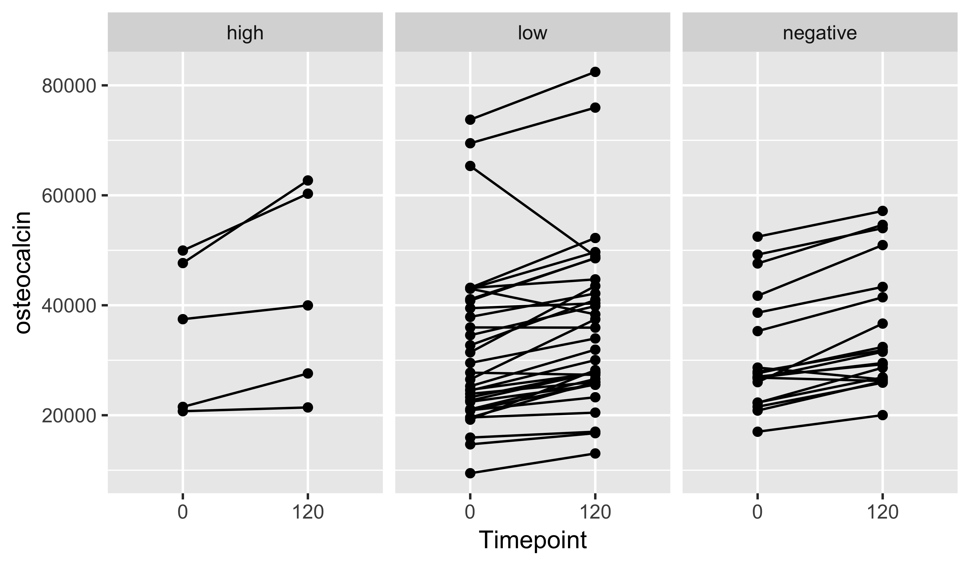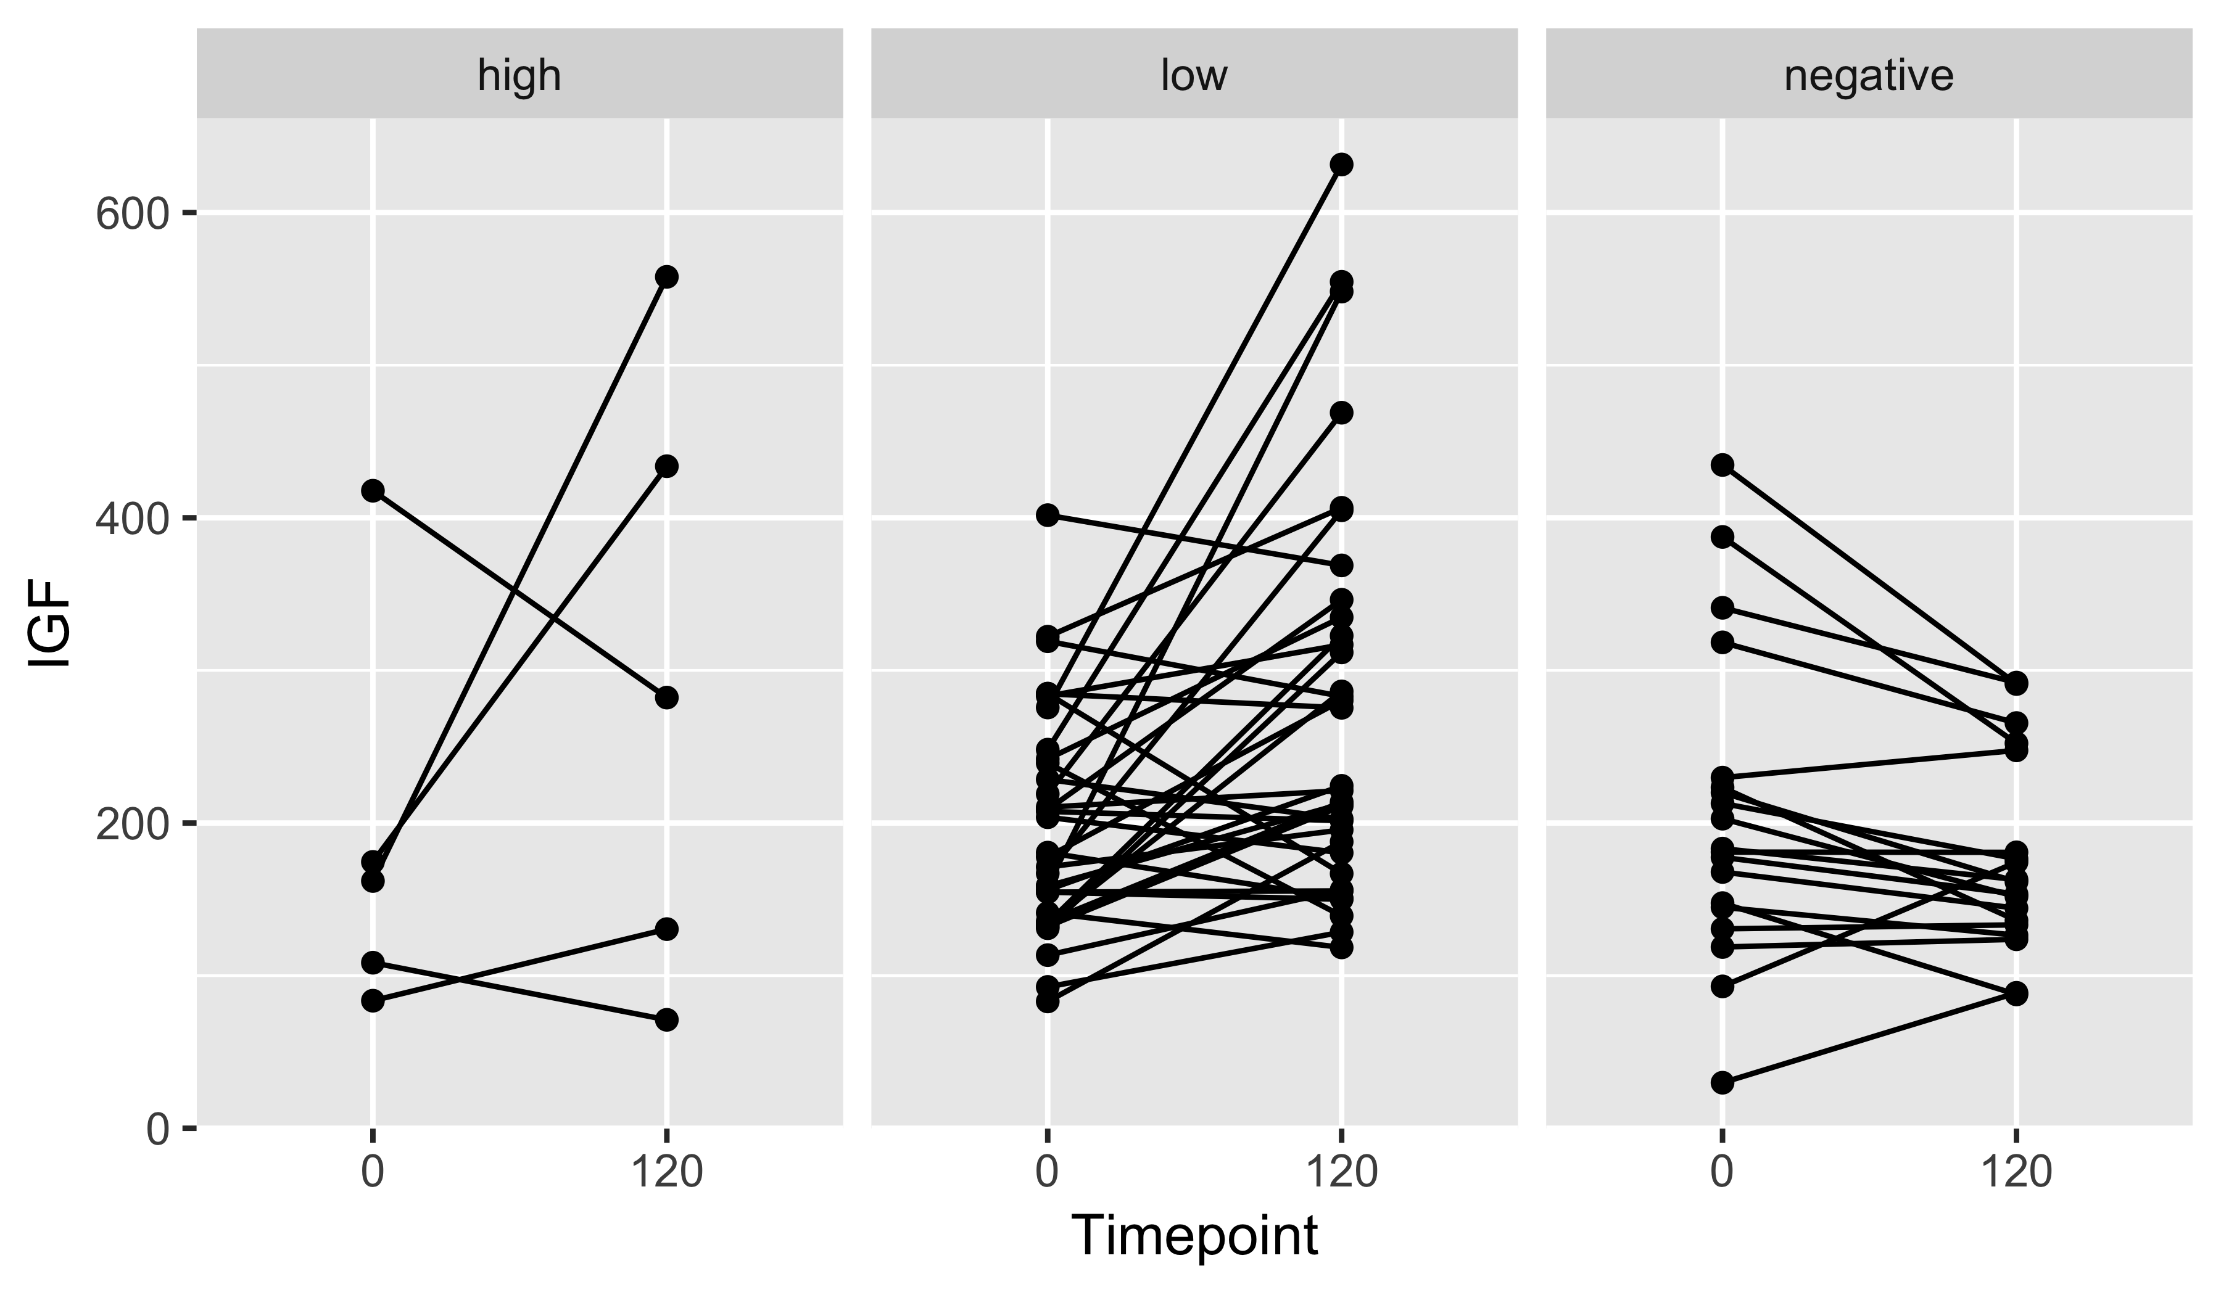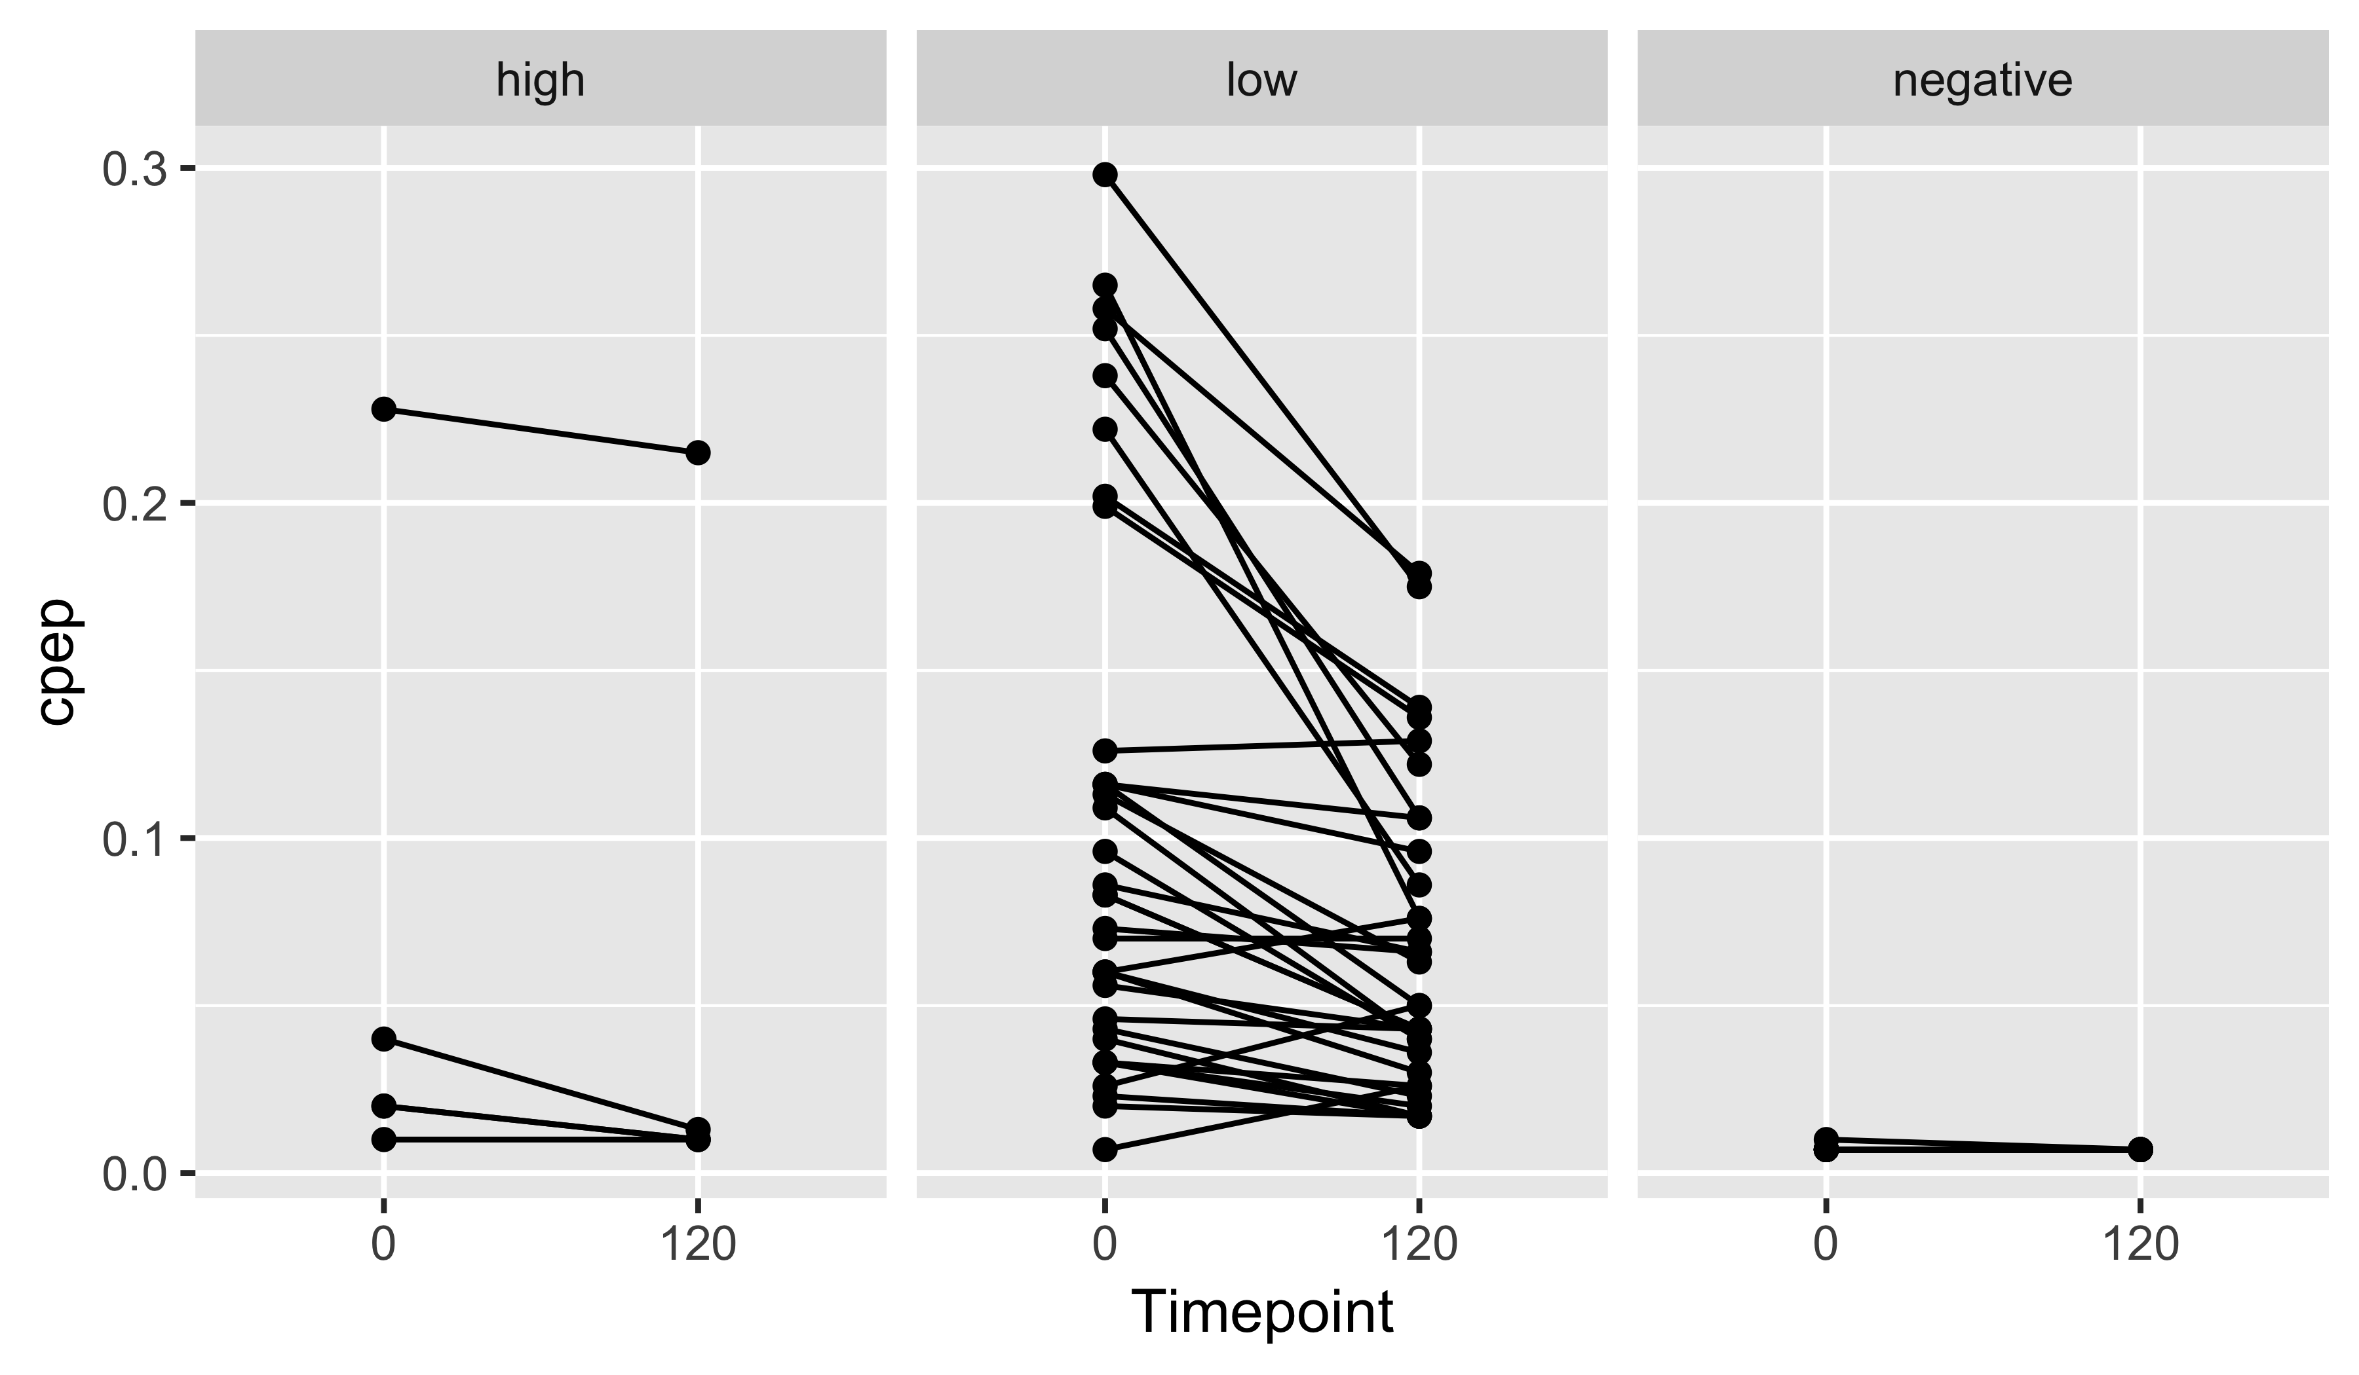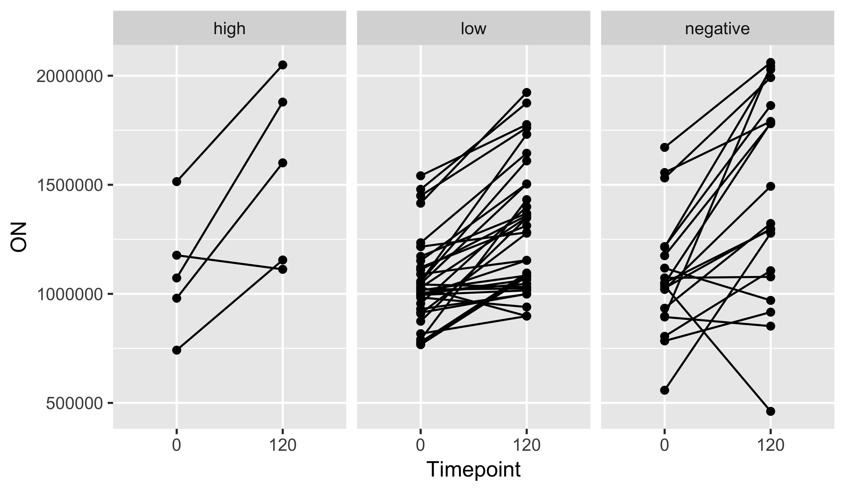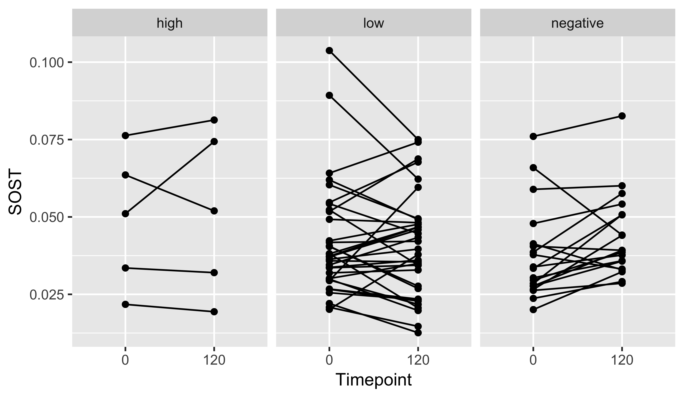

# Linear models of percent change in bone markers and percent change in insulin, adjusted for c-peptide group

### P1NP

|  |  |  |  |  |
| --- | --- | --- | --- | --- |
|  | Estimate | Std. Error | t value | Pr(>|t|) |
| (Intercept) | -26.546 | 38.064 | -0.697 | 0.489 |
| ins_perc_change | 0.018 | 0.016 | 1.090 | 0.281 |
| cpep_grouplow | 18.708 | 40.555 | 0.461 | 0.647 |
| cpep_groupnegative | -4.399 | 42.126 | -0.104 | 0.917 |

Adjusted R Squared: -0.0092

### CTX

|  |  |  |  |  |
| --- | --- | --- | --- | --- |
|  | Estimate | Std. Error | t value | Pr(>|t|) |
| (Intercept) | 26.733 | 22.116 | 1.209 | 0.232 |
| ins_perc_change | -0.005 | 0.009 | -0.518 | 0.606 |
| cpep_grouplow | -37.746 | 23.448 | -1.610 | 0.113 |
| cpep_groupnegative | -42.782 | 24.480 | -1.748 | 0.086 |

Adjusted R Squared: 0.0095

### Osteocalcin

|  |  |  |  |  |
| --- | --- | --- | --- | --- |
|  | Estimate | Std. Error | t value | Pr(>|t|) |
| (Intercept) | 18.522 | 6.101 | 3.036 | 0.004 |
| ins_perc_change | -0.001 | 0.003 | -0.386 | 0.701 |
| cpep_grouplow | -1.972 | 6.468 | -0.305 | 0.762 |
| cpep_groupnegative | -2.357 | 6.753 | -0.349 | 0.728 |

Adjusted R Squared: -0.0499

### IGF

|  |  |  |  |  |
| --- | --- | --- | --- | --- |
|  | Estimate | Std. Error | t value | Pr(>|t|) |
| (Intercept) | 73.041 | 31.331 | 2.331 | 0.023 |
| ins_perc_change | 0.008 | 0.013 | 0.602 | 0.550 |
| cpep_grouplow | -31.697 | 33.218 | -0.954 | 0.344 |
| cpep_groupnegative | -77.333 | 34.679 | -2.230 | 0.030 |

Adjusted R Squared: 0.0817

### ON

|  |  |  |  |  |
| --- | --- | --- | --- | --- |
|  | Estimate | Std. Error | t value | Pr(>|t|) |
| (Intercept) | 0.019 | 0.007 | 2.743 | 0.008 |
| ins_perc_change | 0.000 | 0.000 | 0.597 | 0.553 |
| cpep_grouplow | -0.004 | 0.007 | -0.612 | 0.543 |
| cpep_groupnegative | -0.006 | 0.008 | -0.753 | 0.455 |

Adjusted R Squared: -0.0384

### SOST

|  |  |  |  |  |
| --- | --- | --- | --- | --- |
|  | Estimate | Std. Error | t value | Pr(>|t|) |
| (Intercept) | 903216244.9 | 381909859.9 | 2.365 | 0.022 |
| ins_perc_change | 153442.9 | 163726.7 | 0.937 | 0.353 |
| cpep_grouplow | -320919145.4 | 404917330.3 | -0.793 | 0.432 |
| cpep_groupnegative | 62812822.4 | 422732124.5 | 0.149 | 0.882 |

Adjusted R Squared: 0.0045

# Linear models of percent change in bone markers and percent change in insulin, adjusted for baseline c-peptide concentration

### P1NP

|  |  |  |  |  |
| --- | --- | --- | --- | --- |
|  | Estimate | Std. Error | t value | Pr(>|t|) |
| (Intercept) | -18.495 | 16.783 | -1.102 | 0.275 |
| ins_perc_change | 0.020 | 0.017 | 1.210 | 0.232 |
| cpep0 | -5.060 | 139.993 | -0.036 | 0.971 |

Adjusted R Squared: -0.0083

### CTX

|  |  |  |  |  |
| --- | --- | --- | --- | --- |
|  | Estimate | Std. Error | t value | Pr(>|t|) |
| (Intercept) | -5.672 | 9.716 | -0.584 | 0.562 |
| ins_perc_change | -0.004 | 0.010 | -0.419 | 0.677 |
| cpep0 | -59.395 | 82.476 | -0.720 | 0.474 |

Adjusted R Squared: -0.0194

### Osteocalcin

|  |  |  |  |  |
| --- | --- | --- | --- | --- |
|  | Estimate | Std. Error | t value | Pr(>|t|) |
| (Intercept) | 16.037 | 2.615 | 6.134 | 0.000 |
| ins_perc_change | -0.001 | 0.003 | -0.534 | 0.596 |
| cpep0 | 11.394 | 22.194 | 0.513 | 0.610 |

Adjusted R Squared: -0.0282

### IGF

|  |  |  |  |  |
| --- | --- | --- | --- | --- |
|  | Estimate | Std. Error | t value | Pr(>|t|) |
| (Intercept) | 24.937 | 14.318 | 1.742 | 0.087 |
| ins_perc_change | 0.008 | 0.015 | 0.522 | 0.604 |
| cpep0 | 63.332 | 121.543 | 0.521 | 0.604 |

Adjusted R Squared: -0.0226

### ON

|  |  |  |  |  |
| --- | --- | --- | --- | --- |
|  | Estimate | Std. Error | t value | Pr(>|t|) |
| (Intercept) | 0.014 | 0.003 | 4.786 | 0.000 |
| ins_perc_change | 0.000 | 0.000 | 0.518 | 0.607 |
| cpep0 | 0.005 | 0.026 | 0.184 | 0.855 |

Adjusted R Squared: -0.0295

### SOST

|  |  |  |  |  |
| --- | --- | --- | --- | --- |
|  | Estimate | Std. Error | t value | Pr(>|t|) |
| (Intercept) | 779034753.5 | 167813091.2 | 4.642 | 0.000 |
| ins_perc_change | 132763.4 | 170534.9 | 0.779 | 0.440 |
| cpep0 | -431949709.8 | 1424498189.2 | -0.303 | 0.763 |

Adjusted R Squared: -0.0249